PHP Assignment

**MODULE – 2 HTML, CSS, SQL**

**Exercise 1: User Details Form.**

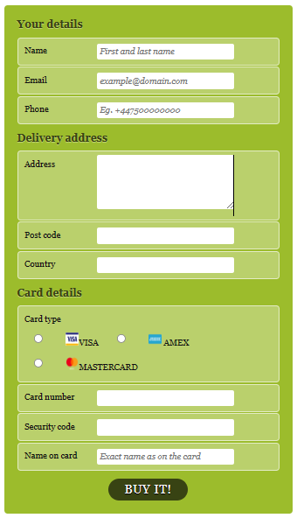

Index1.php :

<!DOCTYPE html>

<html lang="en">

<head>

  <meta charset="UTF-8">

  <meta name="viewport" content="width=device-width, initial-scale=1.0">

  <title>Document</title>

 <link rel="stylesheet" href="style1.css">

</head>

<body>

<form action="index.php" method="post"id=payment>

    <fieldset>

        <legend>Your details</legend>

        <ol>

            <li>

                <label for=name>Name</label>

                <input id=name name=name type=text placeholder="First and last name" required autofocus>

            </li>

            <li>

                <label for=email>Email</label>

                <input id=email name=email type=email placeholder="example@domain.com" required>

            </li>

            <li>

                <label for=phone>Phone</label>

                <input id=phone name=phone type=tel placeholder="Eg. +447500000000" required>

            </li>

        </ol>

    </fieldset>

    <fieldset>

        <legend>Delivery address</legend>

        <ol>

            <li>

                <label for=address>Address</label>

                <textarea id=address name=address rows=5 required></textarea>

            </li>

            <li>

                <label for=postcode>Post code</label>

                <input id=postcode name=postcode type=text required>

            </li>

            <li>

                <label for=country>Country</label>

                <input id=country name=country type=text required>

            </li>

        </ol>

    </fieldset>

    <fieldset>

        <legend>Card details</legend>

        <ol>

            <li>

                <fieldset>

                    <legend>Card type</legend>

                    <ol>

                            <li>

                            <input type="radio" id="visa" name="cardtype">

                            <label for=visa><img src="image\Visa-Logo-Free-Download-PNG.png" height=20px width=20px>VISA<b>&nbsp</b></label>

                            </li>

                            <li>

                            <input type="radio" id="amex" name="cardtype">

                            <label for=amex><img src="image\179431.png" height=20px width=20px><b>&nbsp</b>AMEX</label>

                             </li>

                             <li>

                            <input type="radio" id="mastercard" name="cardtype">

                            <label for=mastercard><img src="image\mcbc_debit-rev_84px.png" height=20px width=20px>MASTERCARD<b>&nbsp</b></label>

                            </li>

                    </ol>

                </fieldset>

            </li>

            <li>

                <label for=cardnumber>Card number</label>

                <input id=cardnumber name=cardnumber type=number required>

            </li>

            <li>

                <label for=secure>Security code</label>

                <input id=secure name=secure type=number required>

            </li>

            <li>

                <label for=namecard>Name on card</label>

                <input id=namecard name=namecard type=text placeholder="Exact name as on the card" required>

            </li>

        </ol>

    </fieldset>

    <fieldset>

        <button type=submit name="submit">Buy it!</button>

    </fieldset>

</form>

</body>

</html>

Style1.css :

html, body, h1, form, fieldset, legend, ol, li {

    margin:0;

    padding:0;

}

body {

    background-image:url(image/ishita.jpg);

     font-family: Georgia, "Times New Roman", Times, serif;

    background-repeat: no-repeat;

    background-attachment: fixed;

    background-position: center;

    color: #111111;

    padding: 20px;

}

form#payment {

    margin:auto;

    background: #9cbc2c;

    -moz-border-radius: 5px;

    -webkit-border-radius: 5px;

    border-radius: 5px;

    padding: 20px;

    width: 400px;

}

form#payment fieldset {

    border: none;

    margin-bottom: 10px;

}

form#payment fieldset:last-of-type {

    margin-bottom: 0;

}

form#payment legend {

    color: #384313;

    font-size: 16px;

    font-weight: bold;

    padding-bottom: 10px;

    text-shadow: 0 1px 1px #c0d576;

}

form#payment fieldset fieldset legend {

    color: #111111;

    font-size: 13px;

    font-weight: normal;

    padding-bottom: 0;

}

form#payment ol li {

    background: #b9cf6a;

    background: rgba(255,255,255,.3);

    border-color: #e3ebc3;

    border-color: rgba(255,255,255,.6);

    border-style: solid;

    border-width: 2px;

    -moz-border-radius: 5px;

    -webkit-border-radius: 5px;

    border-radius: 5px;

    line-height: 30px;

    list-style: none;

    padding: 5px 10px;

    margin-bottom: 2px;

}

form#payment ol ol li {

    background: none;

    border: none;

    float: left;

}

form#payment label {

    float: left;

    font-size: 13px;

    width: 110px;

}

form#payment fieldset fieldset label {

    background:none no-repeat left 50%;

    line-height: 20px;

    padding: 0 0 0 30px;

    width: auto;

}

form#payment label[for=visa] {

    background-image: url();

}

form#payment label[for=amex] {

        background-image: url();

}

form#payment label[for=mastercard] {

    background-image: url();

}

form#payment fieldset fieldset label:hover {

    cursor: pointer;

}

form#payment input:not([type=radio]),

form#payment textarea {

    background: #ffffff;

    border: none;

    -moz-border-radius: 3px;

    -webkit-border-radius: 3px;

    -khtml-border-radius: 3px;

    border-radius: 3px;

    font: italic 13px Georgia, "Times New Roman", Times, serif;

    outline: none;

    padding: 5px;

    width: 200px;

}

form#payment input:not([type=submit]):focus,

form#payment textarea:focus {

    background: #eaeaea;

}

form#payment input[type=radio] {

    float: left;

    margin-right: 5px;

}

form#payment button {

    background: #384313;

    border: none;

    -moz-border-radius: 20px;

    -webkit-border-radius: 20px;

    -khtml-border-radius: 20px;

    border-radius: 20px;

    color: #ffffff;

    display: block;

    font: 18px Georgia, "Times New Roman", Times, serif;

    letter-spacing: 1px;

    margin: auto;

    padding: 7px 25px;

    text-shadow: 0 1px 1px #000000;

    text-transform: uppercase;

}

form#payment button:hover {

    background: #1e2506;

    cursor: pointer;

}

**BOOTSRAP**

**Exercise 1 : Create Manage Profile :**

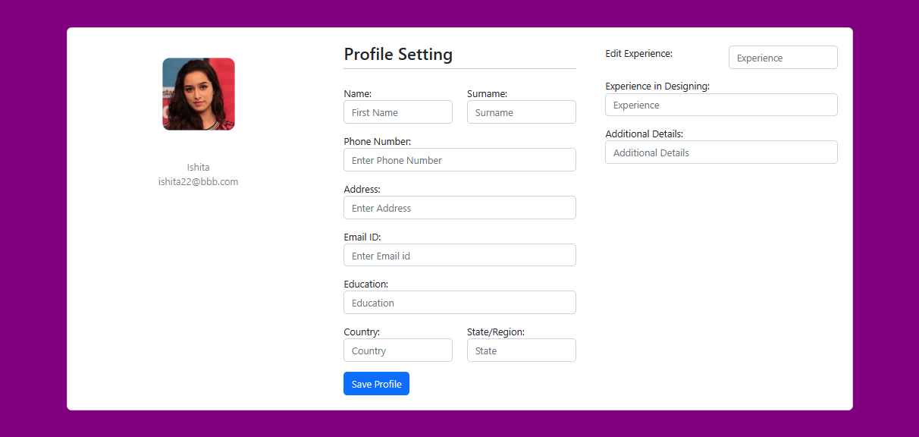

Bootsrap_form.php

<!DOCTYPE html>

<html lang="en">

<head>

  <title>Bootstrap Example</title>

  <meta charset="utf-8">

  <meta name="viewport" content="width=device-width, initial-scale=1">

  <link href="https://cdn.jsdelivr.net/npm/bootstrap@5.2.3/dist/css/bootstrap.min.css" rel="stylesheet">

  <script src="https://cdn.jsdelivr.net/npm/bootstrap@5.2.3/dist/js/bootstrap.bundle.min.js"></script>

</head>

<body>

<section class="vh-150" style="background-color: purple;">

  <div class="container py-5 h-100">

    <div class="row d-flex justify-content-center align-items-center h-100">

      <div class="col col-lg-12 mb-4 mb-lg-0">

        <div class="card mb-3" style="border-radius: .5rem;">

          <div class="row g-0">

               <!-- 0 -->

            <div class="col-md-4 gradient-custom text-center text-white"

              style="border-top-left-radius: .5rem; border-bottom-left-radius: .5rem;">

              <img src="image\shrddha.jpg"

                alt="image.jpg" class="img-fluid my-5" style="width: 120px;"><br>

             <span class="text-black-50" size="font-weight-bold">Ishita</span><br>

            <span class="text-black-50">ishita22@bbb.com</span>

            <span>

            </span>

            </div>

            <!-- 1-->

            <div class="col-md-4">

              <div class="card-body p-4">

               <h3>Profile Setting</h3>

                 <hr class="mt-0 mb-4">

                <div class="row pt-1">

                  <div class="col-6 mb-3">

                    <label for="TEXT">Name:</label>

      <input type="TEXT" class="form-control" id="TEXT" placeholder="First Name" name="TEXT">

                  </div>

                  <div class="col-6 mb-3">

                     <label for="TEXT">Surname:</label>

      <input type="TEXT" class="form-control" id="TEXT" placeholder="Surname" name="TEXT">

                  </div>

                   <div class="col-12 mb-3">

                     <label for="TEXT">Phone Number:</label>

      <input type="TEXT" class="form-control" id="TEXT" placeholder="Enter Phone Number" name="TEXT">

                  </div>

                   <div class="col-12 mb-3">

                     <label for="TEXT">Address:</label>

      <input type="TEXT" class="form-control" id="TEXT" placeholder="Enter Address" name="TEXT">

                  </div>

                  <div class="col-12 mb-3">

                     <label for="TEXT">Email ID:</label>

      <input type="TEXT" class="form-control" id="TEXT" placeholder="Enter Email id" name="TEXT">

                  </div>

                  <div class="col-12 mb-3">

                     <label for="TEXT">Education:</label>

      <input type="TEXT" class="form-control" id="TEXT" placeholder="Education" name="TEXT">

                  </div>

                  <div class="col-6 mb-3">

                    <label for="TEXT">Country:</label>

      <input type="TEXT" class="form-control" id="TEXT" placeholder="Country" name="TEXT">

                  </div>

                  <div class="col-6 mb-3">

                     <label for="TEXT">State/Region:</label>

      <input type="TEXT" class="form-control" id="TEXT" placeholder="State" name="TEXT">

                  </div>

                  <div>

                    <input type="submit" name="submit" value="Save Profile" class="btn btn-primary">

                   </div>

                   </div>

          </div>

        </div>

         <!-- 3 -->

       <div class="col-md-4">

              <div class="card-body p-4">

                <div class="row pt-1">

                  <div class="col-6 mb-3">

                    <label for="TEXT">Edit Experience:</label>

                  </div>

                  <div class="col-6 mb-3">

      <input type="TEXT" class="form-control" id="TEXT" placeholder="Experience" name="TEXT">

                  </div>

                   <div class="col-12 mb-3">

                     <label for="TEXT">Experience in Designing:</label>

      <input type="TEXT" class="form-control" id="TEXT" placeholder="Experience" name="TEXT">

                  </div>

                   <div class="col-12 mb-3">

                     <label for="TEXT">Additional Details:</label>

      <input type="TEXT" class="form-control" id="TEXT" placeholder="Additional Details" name="TEXT">

                  </div>

                  </div>

                   </div>

          </div>

        </div>

            </div>

      </div>

    </div>

  </div>

</section>

</body>

</html>

**Exercise 2 : Create ProductListing Page:**

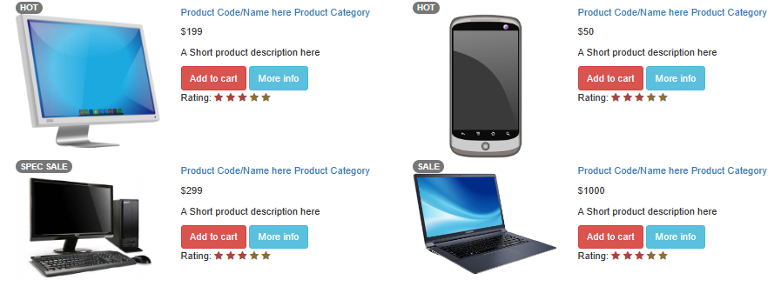

Productlisting.php :

<!DOCTYPE html>

<html>

<head>

<link rel="stylesheet" href="https://maxcdn.bootstrapcdn.com/bootstrap/3.3.5/css/bootstrap.min.css" integrity="sha512-dTfge/zgoMYpP7QbHy4gWMEGsbsdZeCXz7irItjcC3sPUFtf0kuFbDz/ixG7ArTxmDjLXDmezHubeNikyKGVyQ==" crossorigin="anonymous">

<link href="https://maxcdn.bootstrapcdn.com/font-awesome/4.3.0/css/font-awesome.min.css" rel="stylesheet">

<link rel="stylesheet" href="">

</head>

<body>

<div class="container">

<div class="col-xs-12 col-md-6">

    <!-- First product box start here-->

    <div class="prod-info-main prod-wrap clearfix">

        <div class="row">

                <div class="col-md-5 col-sm-12 col-xs-12">

                    <div class="product-image">

                    <span class="badge rounded-pill text-bg-danger">HOT</span>

                        <img src="image\1724818.png" class="img-responsive">

                    </div>

                </div>

                <div class="col-md-7 col-sm-12 col-xs-12">

                <div class="product-deatil">

                        <h5 class="name">

                            <a href="#">

                                Product Code/Name here

                            </a>

                            <a href="#">

                                <span>Product Category</span>

                            </a>

                        </h5>

                        <p class="price-container">

                            <span>$199</span>

                        </p>

                        <span class="tag1"></span>

                </div>

                <div class="description">

                    <p>A Short product description here </p>

                </div>

                <div class="product-info smart-form">

                    <div class="row">

                        <div class="col-md-12">

                            <a href="javascript:void(0);" class="btn btn-danger">Add to cart</a>

                            <a href="javascript:void(0);" class="btn btn-info">More info</a>

                        </div>

                        <div class="col-md-12">

                            <div class="rating">Rating:

                                <label for="stars-rating-5"><i class="fa fa-star text-danger"></i></label>

                                <label for="stars-rating-4"><i class="fa fa-star text-danger"></i></label>

                                <label for="stars-rating-3"><i class="fa fa-star text-danger"></i></label>

                                <label for="stars-rating-2"><i class="fa fa-star text-warning"></i></label>

                                <label for="stars-rating-1"><i class="fa fa-star text-warning"></i></label>

                            </div>

                        </div>

                    </div>

                </div>

            </div>

        </div>

    </div>

    <!-- end product -->

</div>

<div class="col-xs-12 col-md-6">

    <!-- First product box start here-->

    <div class="prod-info-main prod-wrap clearfix">

        <div class="row">

                <div class="col-md-5 col-sm-12 col-xs-12">

                    <div class="product-image">

                    <span class="badge rounded-pill text-bg-danger">HOT</span>

                        <img src="image\png-mobile-phone-cell-phone-clipart-1000.png" alt="194x228" class="img-responsive">

                    </div>

                </div>

                <div class="col-md-7 col-sm-12 col-xs-12">

                <div class="product-deatil">

                        <h5 class="name">

                            <a href="#">

                                Product Code/Name here <span>Product Category</span>

                            </a>

                        </h5>

                        <p class="price-container">

                            <span>$50</span>

                        </p>

                        <span class="tag1"></span>

                </div>

                <div class="description">

                    <p>A Short product description here </p>

                </div>

                <div class="product-info smart-form">

                    <div class="row">

                        <div class="col-md-12">

                            <a href="javascript:void(0);" class="btn btn-danger">Add to cart</a>

                            <a href="javascript:void(0);" class="btn btn-info">More info</a>

                        </div>

                        <div class="col-md-12">

                            <div class="rating">Rating:

                                <label for="stars-rating-5"><i class="fa fa-star text-danger"></i></label>

                                <label for="stars-rating-4"><i class="fa fa-star text-danger"></i></label>

                                <label for="stars-rating-3"><i class="fa fa-star text-danger"></i></label>

                                <label for="stars-rating-2"><i class="fa fa-star text-warning"></i></label>

                                <label for="stars-rating-1"><i class="fa fa-star text-warning"></i></label>

                            </div>

                        </div>

                    </div>

                </div>

            </div>

        </div>

    </div>

    <!-- end product -->

</div>

<div class="col-xs-12 col-md-6">

<!-- First product box start here-->

    <div class="prod-info-main prod-wrap clearfix">

        <div class="row">

                <div class="col-md-5 col-sm-12 col-xs-12">

                    <div class="product-image">

                    <span class="badge rounded-pill text-bg-danger">SPEC SALE</span>

                        <img src="image\computer.jpg" alt="194x228" class="img-responsive">

                    </div>

                </div>

                <div class="col-md-7 col-sm-12 col-xs-12">

                <div class="product-deatil">

                        <h5 class="name">

                            <a href="#">

                                Product Code/Name here <span>Product Category</span>

                            </a>

                        </h5>

                        <p class="price-container">

                            <span>$299</span>

                        </p>

                        <span class="tag1"></span>

                </div>

                <div class="description">

                    <p>A Short product description here </p>

                </div>

                <div class="product-info smart-form">

                    <div class="row">

                        <div class="col-md-12">

                            <a href="javascript:void(0);" class="btn btn-danger">Add to cart</a>

                            <a href="javascript:void(0);" class="btn btn-info">More info</a>

                        </div>

                        <div class="col-md-12">

                            <div class="rating">Rating:

                                <label for="stars-rating-5"><i class="fa fa-star text-danger"></i></label>

                                <label for="stars-rating-4"><i class="fa fa-star text-danger"></i></label>

                                <label for="stars-rating-3"><i class="fa fa-star text-danger"></i></label>

                                <label for="stars-rating-2"><i class="fa fa-star text-warning"></i></label>

                                <label for="stars-rating-1"><i class="fa fa-star text-warning"></i></label>

                            </div>

                        </div>

                    </div>

                </div>

            </div>

        </div>

    </div>

    <!-- end product -->

</div>

<div class="col-xs-12 col-md-6">

    <!-- First product box start here-->

    <div class="prod-info-main prod-wrap clearfix">

        <div class="row">

                <div class="col-md-5 col-sm-12 col-xs-12">

                    <div class="product-image">

                    <span class="badge rounded-pill text-bg-danger">SALE</span>

                        <img src="image\laptop-png-4.png" alt="194x228" class="img-responsive">

                    </div>

                </div>

                <div class="col-md-7 col-sm-12 col-xs-12">

                <div class="product-deatil">

                        <h5 class="name">

                            <a href="#">

                                Product Code/Name here <span>Product Category</span>

                            </a>

                        </h5>

                        <p class="price-container">

                            <span>$1000</span>

                        </p>

                        <span class="tag1"></span>

                </div>

                <div class="description">

                    <p>A Short product description here </p>

                </div>

                <div class="product-info smart-form">

                    <div class="row">

                        <div class="col-md-12">

                            <a href="javascript:void(0);" class="btn btn-danger">Add to cart</a>

                            <a href="javascript:void(0);" class="btn btn-info">More info</a>

                        </div>

                        <div class="col-md-12">

                            <div class="rating">Rating:

                                <label for="stars-rating-5"><i class="fa fa-star text-danger"></i></label>

                                <label for="stars-rating-4"><i class="fa fa-star text-danger"></i></label>

                                <label for="stars-rating-3"><i class="fa fa-star text-danger"></i></label>

                                <label for="stars-rating-2"><i class="fa fa-star text-warning"></i></label>

                                <label for="stars-rating-1"><i class="fa fa-star text-warning"></i></label>

                            </div>

                        </div>

                    </div>

                </div>

            </div>

        </div>

    </div>

    <!-- end product -->

</div>

</div>

</body>

</html>

**Topic – SQL Task – 1**

TABLE : - Employee

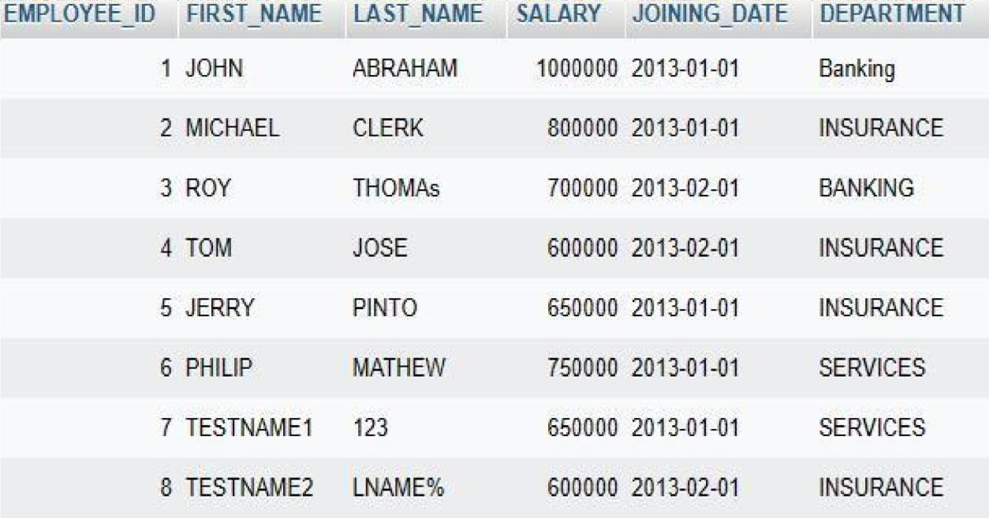

TABLE :- Incentives

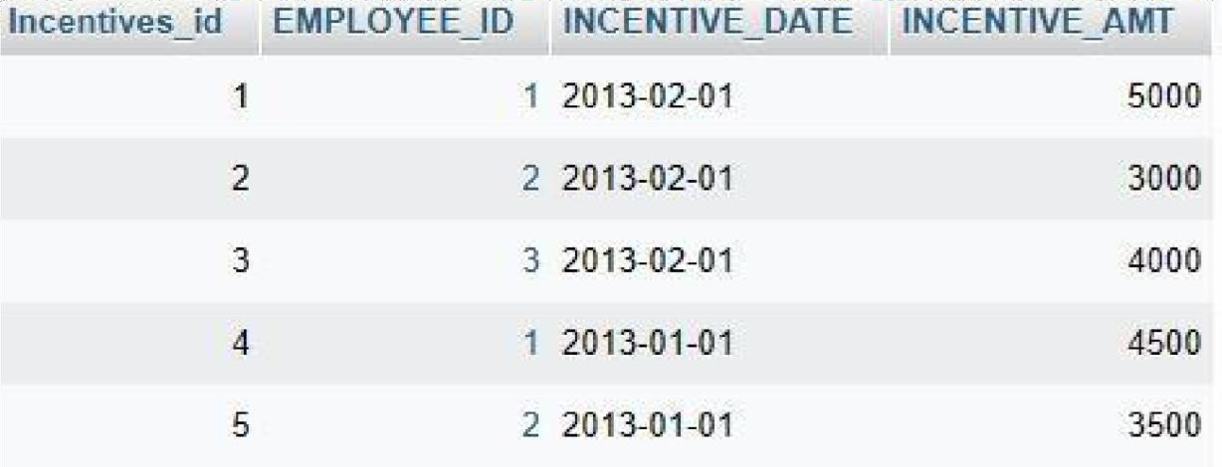

**QUERIES**

1. Get First_name from employee table using alias name “Employee Name”.

➢SELECT First_Name AS "Employee Name" FROM

Employee;

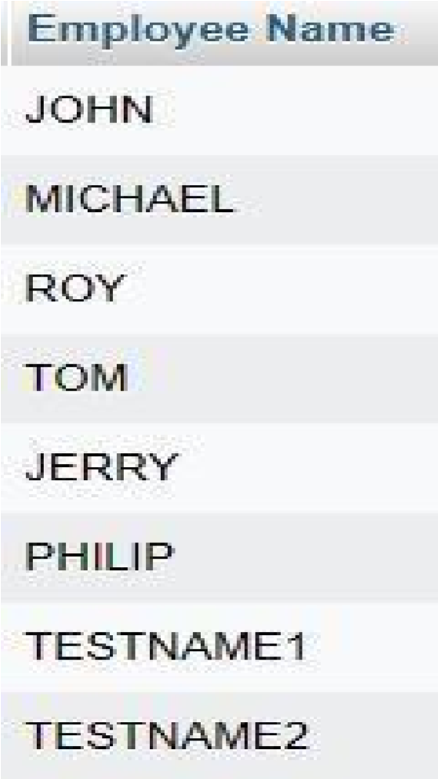

1. Get FIRST_NAME, Joining year, Joining

Month and Joining Date from employee

table.

➢SELECT

FIRST_NAME,

YEAR(JOINING_DATE) AS Joining_Year,

MONTH(JOINING_DATE) AS Joining_Month,

DAY(JOINING_DATE) AS Joining_Date

FROM employee;

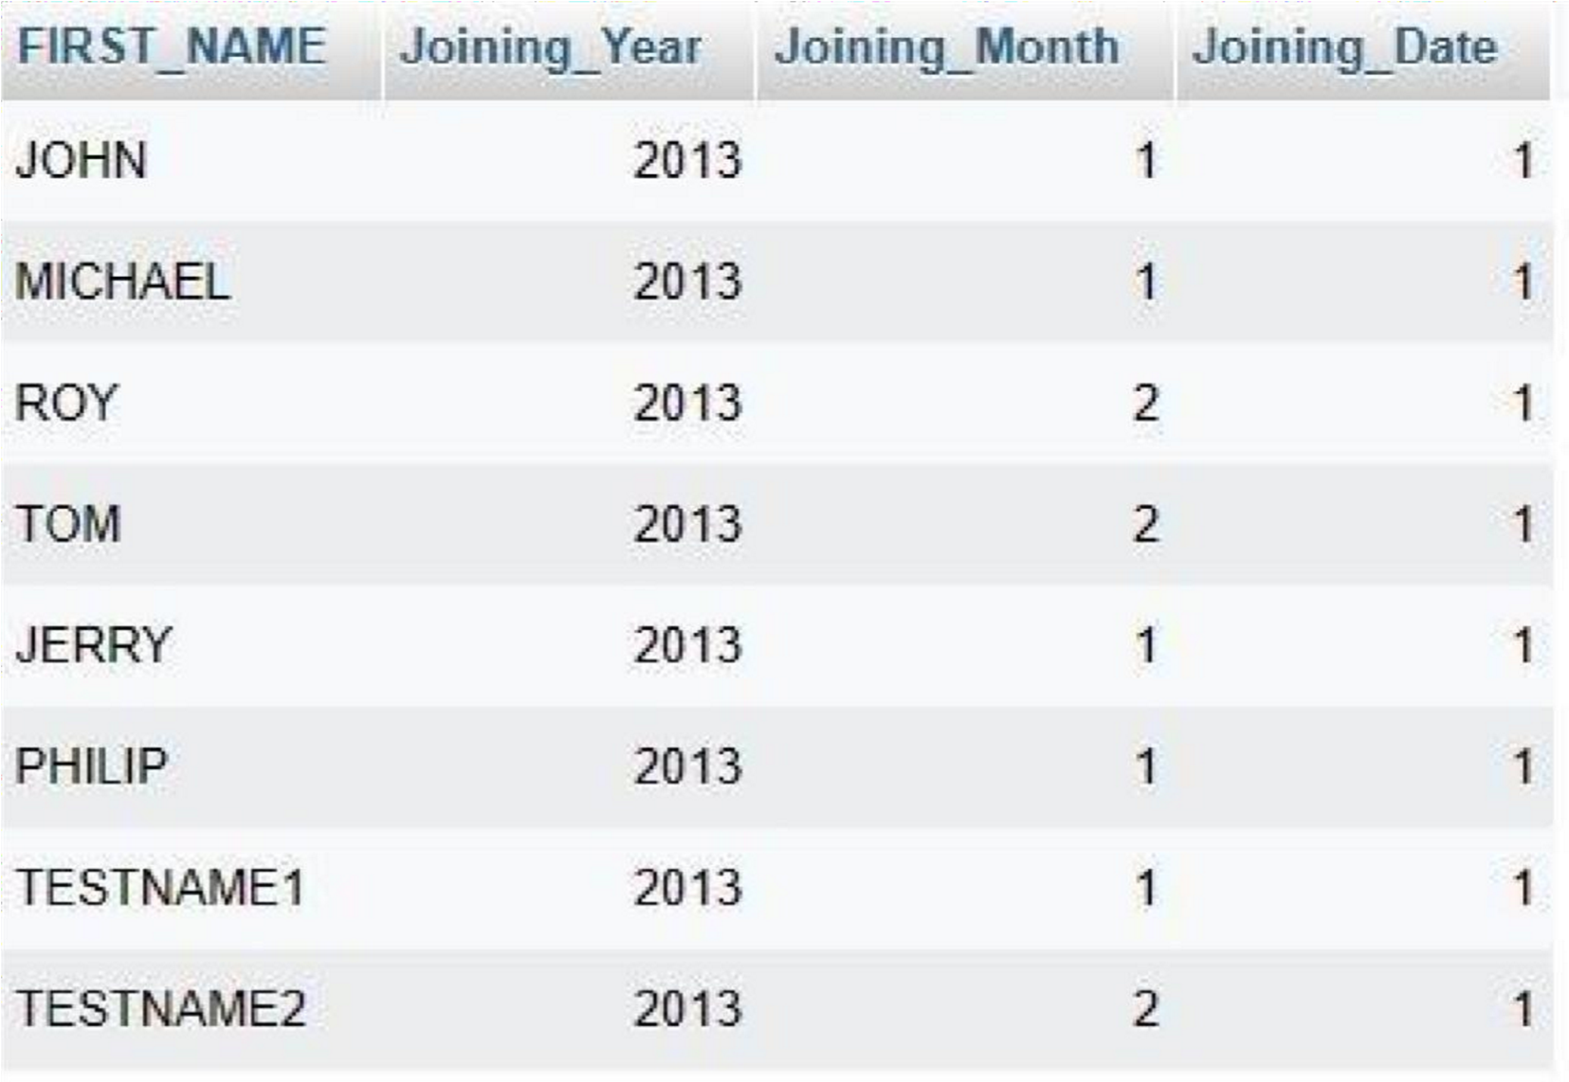

C) Get all employee details from the employee table order by First Name Ascending and Salary descending?

➢SELECT * FROM employee ORDER BY

FIRST_NAME ASC,Salary DESC;

1. Get employee details from employee table whose first name contains “o”. 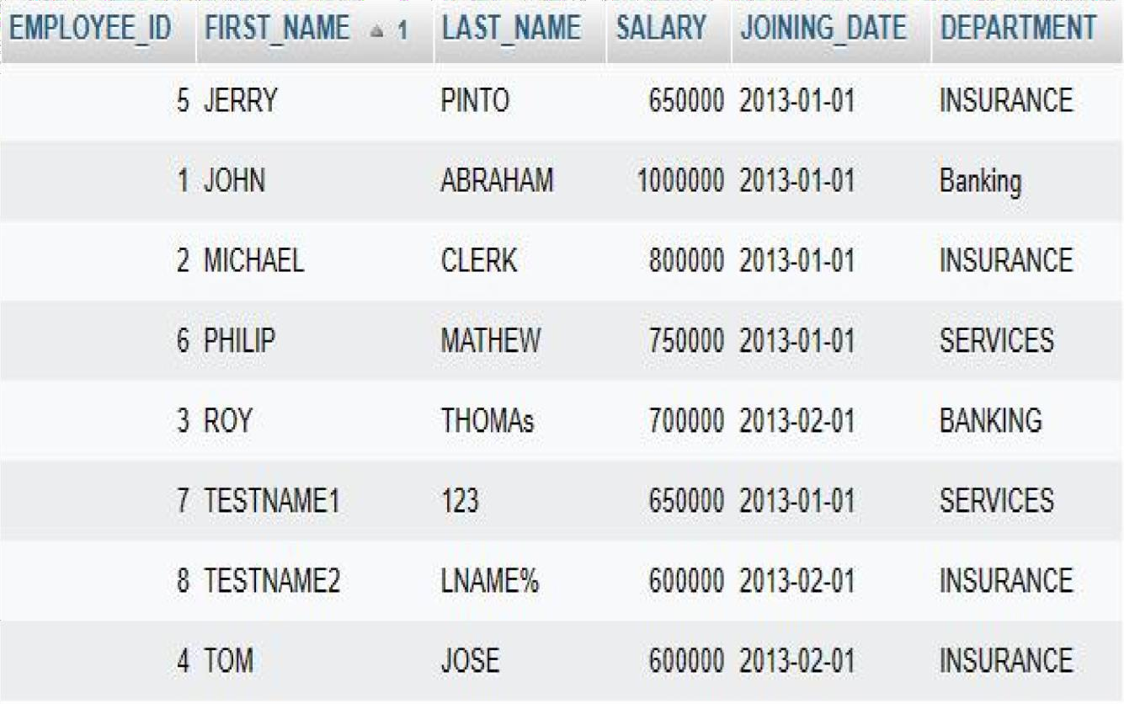

➢SELECT * FROM employee where FIRST_NAME

LIKE '%o%';

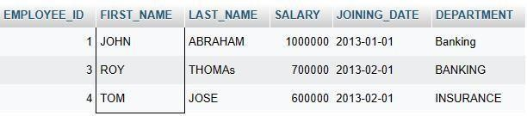

1. Get employee details from employee table whose joining month is “January”.

➢SELECT * FROM employee WHERE

MONTH(Joining_date)=1;

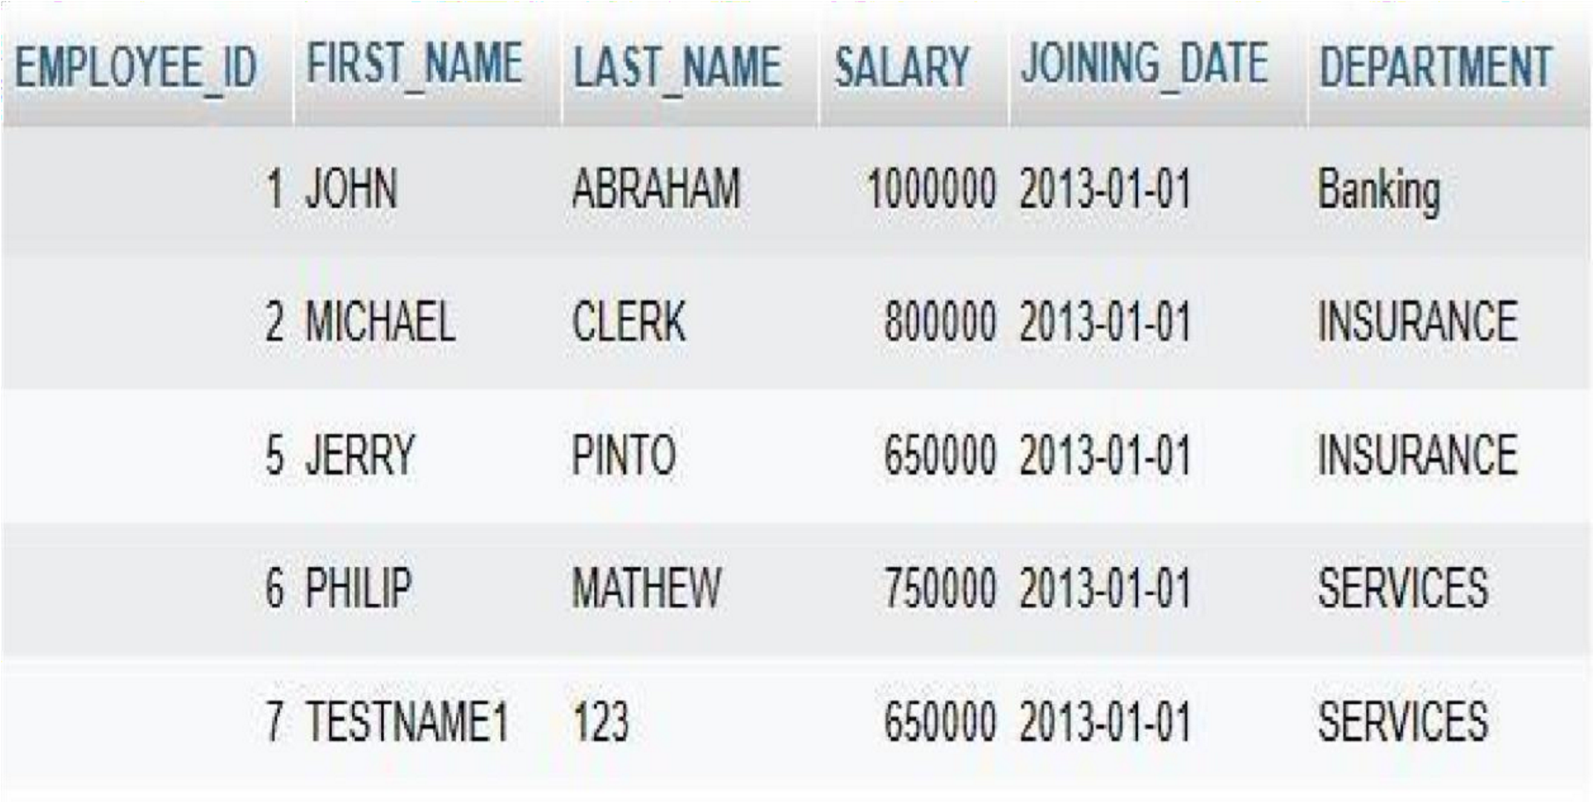

1. Get department, total salary with respect to a department from employee table order by total salary descending.

➢SELECT department, SUM(salary) AS total_salary FROM employee GROUP BY department ORDER

By total_salary DESC;

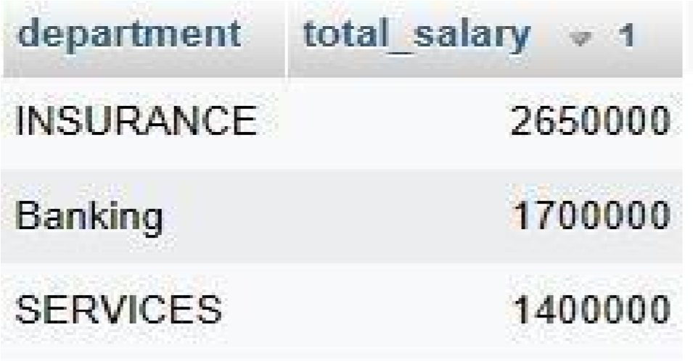

1. Get department wise maximum salary from employee table order by salary Ascending.

➢SELECT department ,MAX(salary) AS max_salary

FROM employee GROUP BY department ORDER

BY max_salary ASC;

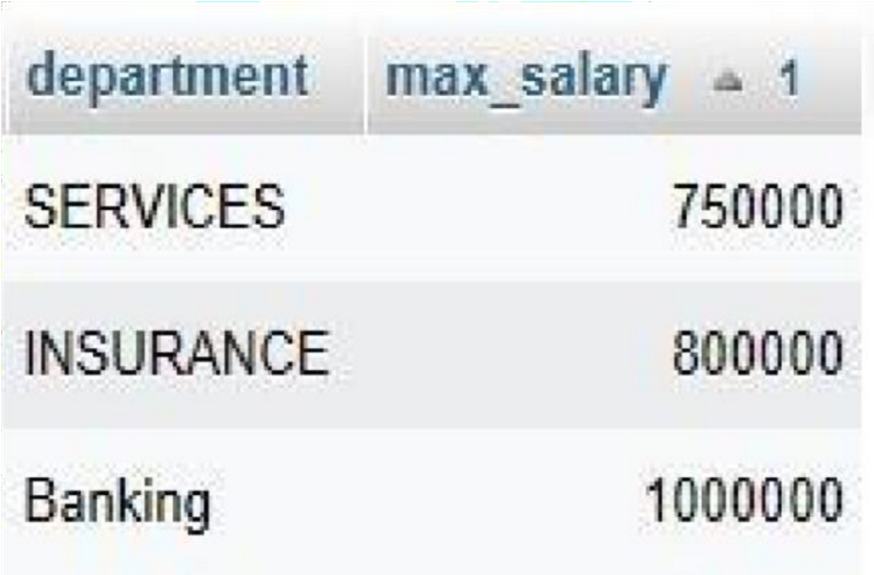

1. Select first_name,incentive amount from employee and incentives table for those employees who have incentives and incentive amount greater than 3000.

➢SELECT e.FIRST_NAME, i.INCENTIVE_AMT

FROM employee e

JOIN incentives i ON e.employee_id = i.employee_id

WHERE i.INCENTIVE_AMT > 3000;

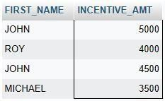

1. Select 2nd Highest salary from employee table.

➢SELECT MAX(salary) AS second_highest_salary FROM employee WHERE salary < (SELECT

MAX(salary) FROM employee);

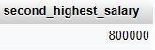

1. Select first_name, incentive amount from employee and incentives table for all Employee who got incentives using left join.

➢SELECT e.FIRST_NAME, i.INCENTIVE_AMT

FROM employee e

LEFT JOIN incentives i ON e.employee_id =

i.employee_id;

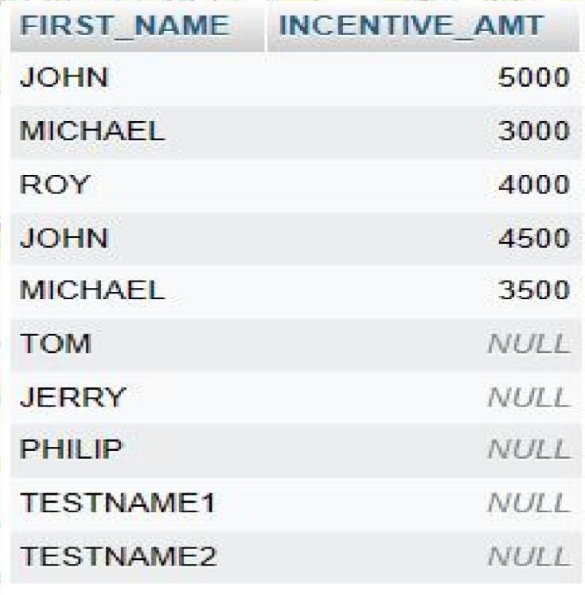

1. Create View OF Employee table in which store first name, last name and salary only.
   * CREATE VIEW EmployeeView AS

SELECT first_name, last_name, salary

FROM Employee;

* + Select *From employeeview;

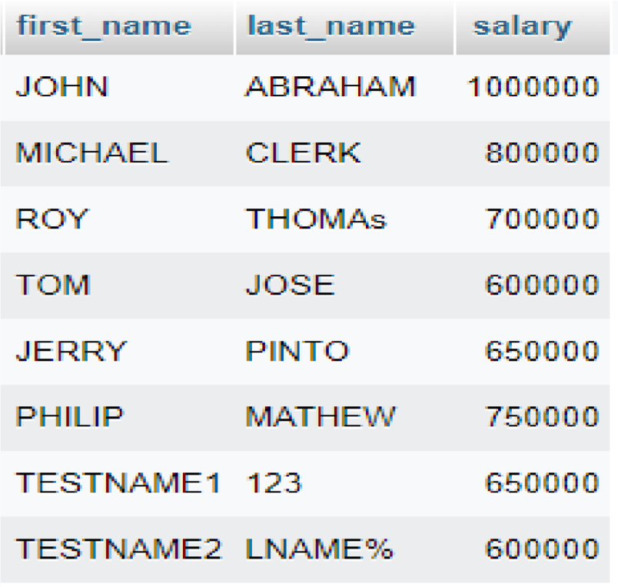

L) Create Procedure to find out department wise highest salary.

m) Create After Insert trigger on Employee table which insert records in view table.

**Task-2:**

TABLE – SALES PERSON

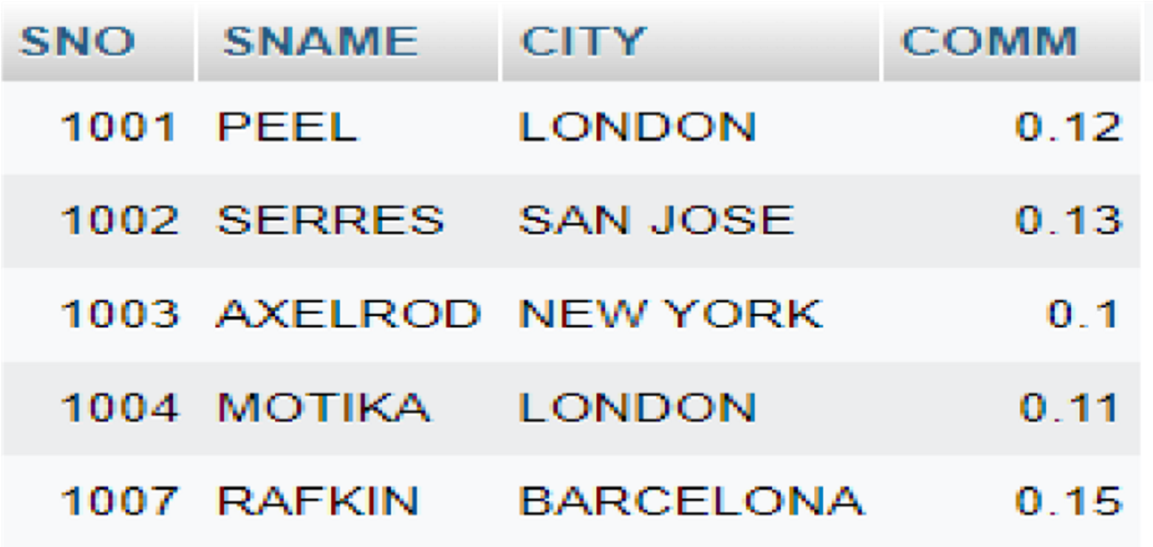

TABLE – CUSTOMER

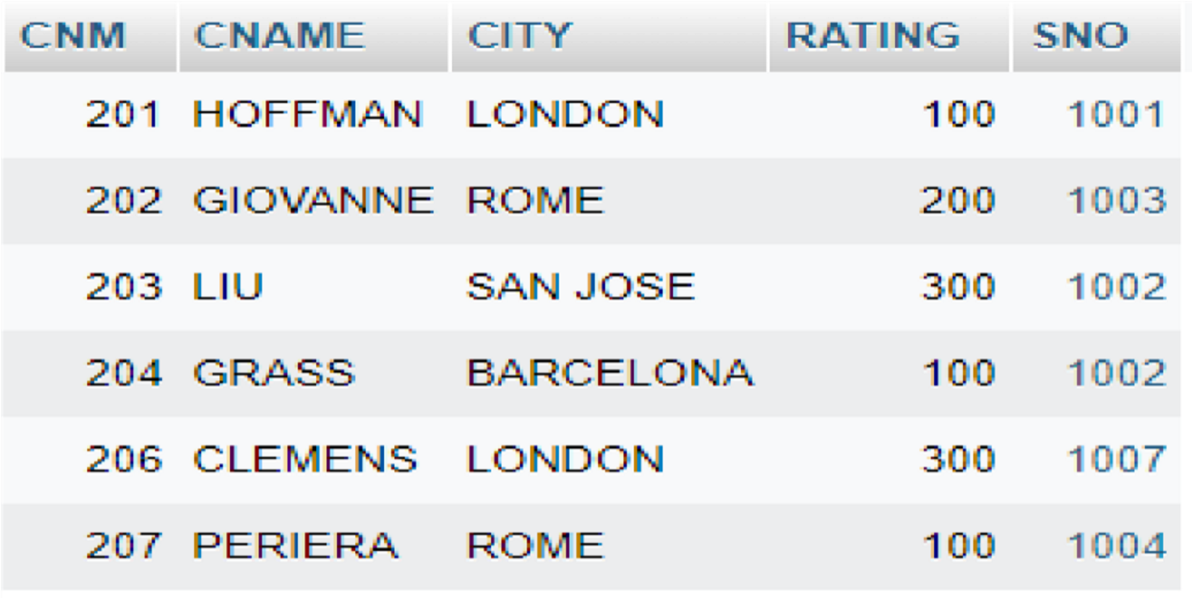

TABLE – ORDER

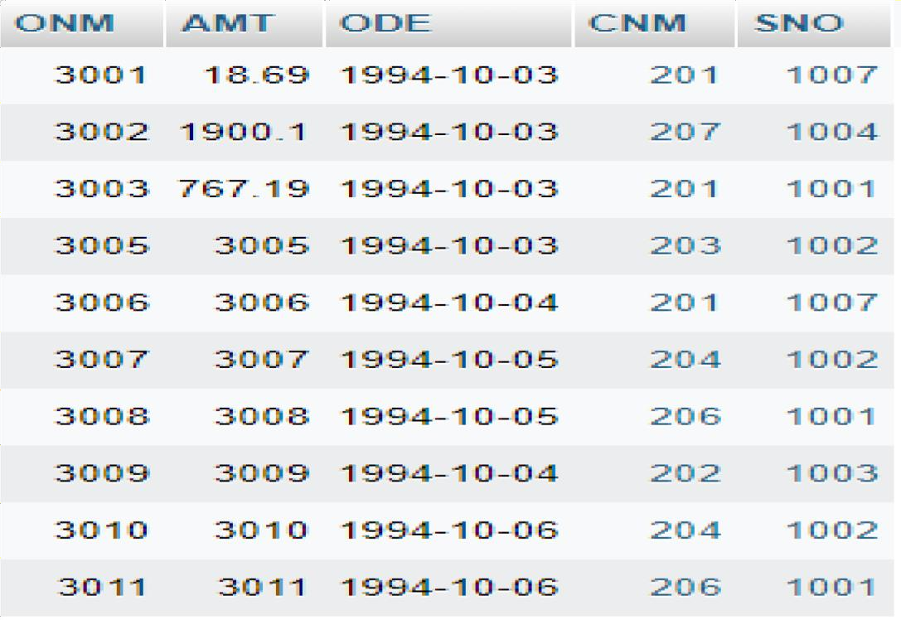

**QUERIES**

1. All orders for more than $1000.

➢ SELECT * FROM orders WHERE AMT

> 1000;

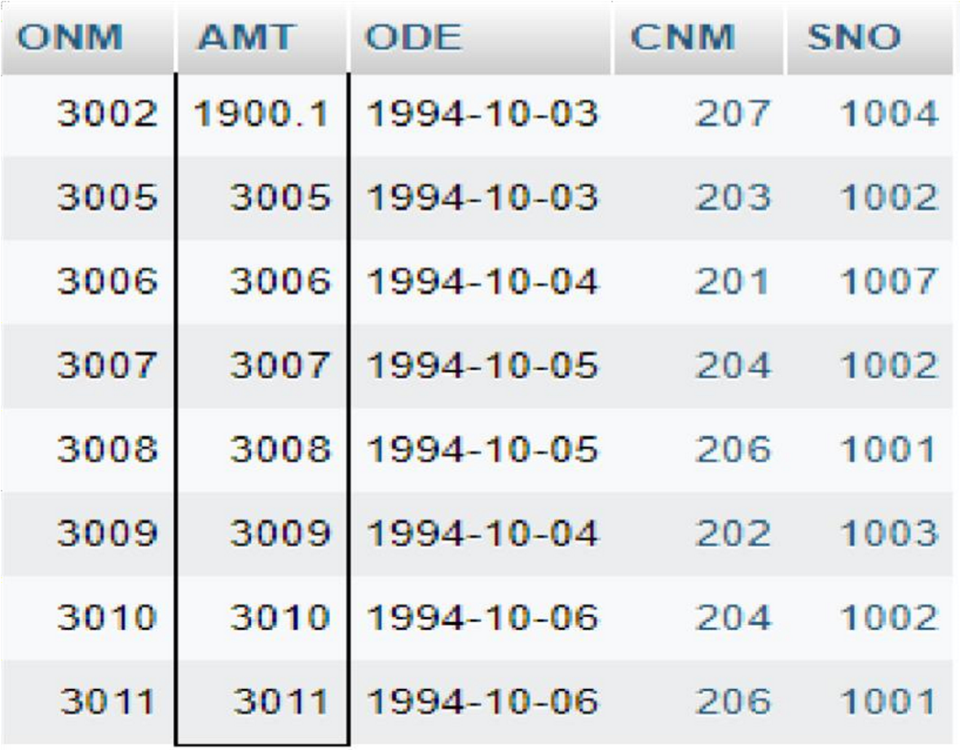

1. Names and cities of all salespeople in London with commission above 0.10.
   * SELECT SNAME, CITY FROM salesperson

WHERE CITY = 'LONDON' AND COMM > 0.10;

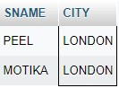

1. All salespeople either in Barcelona or in London.
   * SELECT * FROM salesperson WHERE city IN

('Barcelona', 'London');

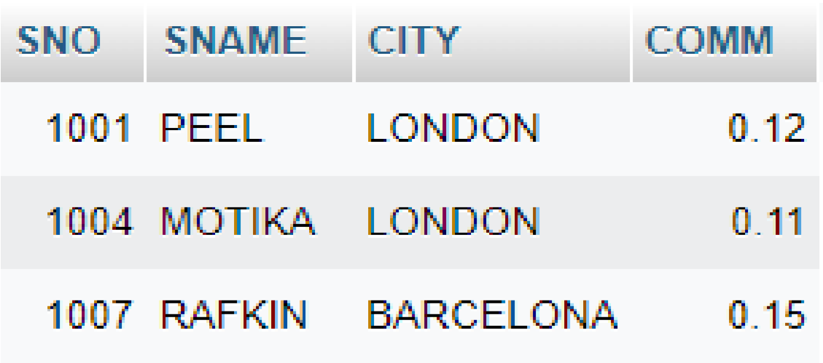

1. All salespeople with commission between 0.10 and 0.12. (Boundary values should be excluded).
   * SELECT * FROM salesperson WHERE COMM

BETWEEN 0.10 and 0.12;

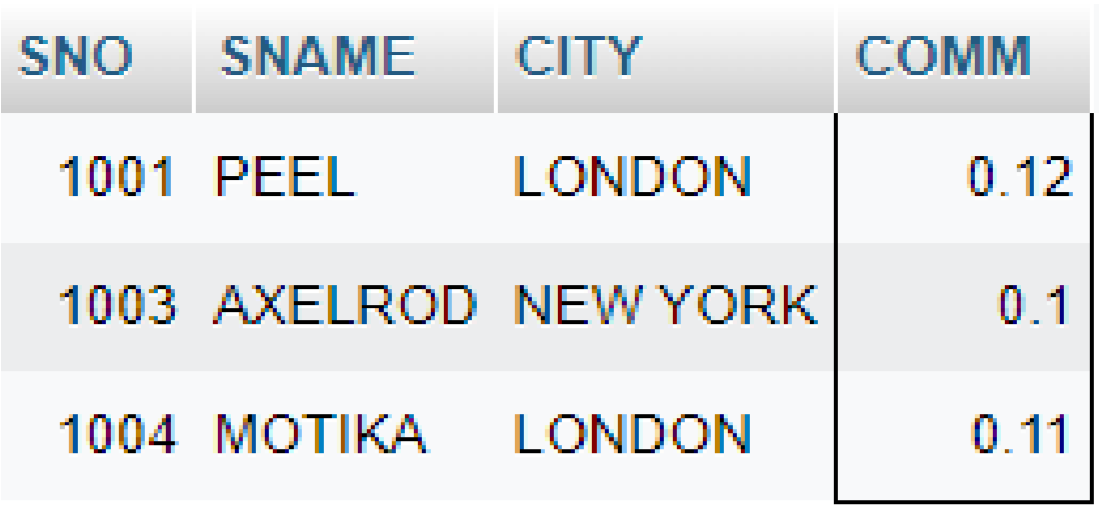

1. All customers with NULL values in city column.
   * SELECT * FROM customer WHERE CITY IS NULL;



1. All orders taken on Oct 3rd and Oct 4th 1994.
   * SELECT * FROM orders WHERE ODE BETWEEN

‘1994-10-03’ AND ‘1994-10-04’;

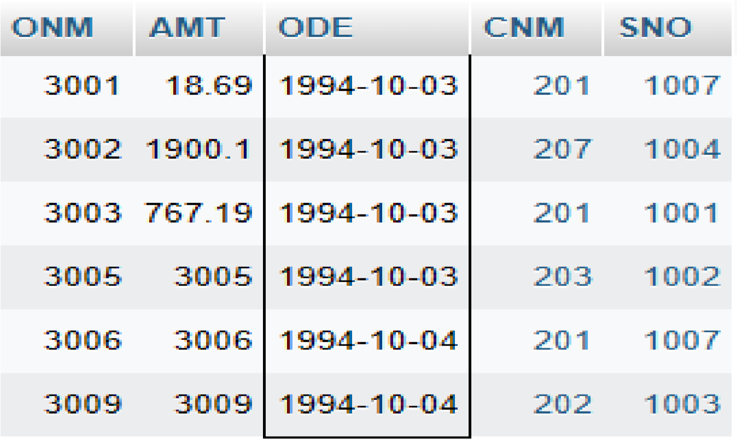

1. All customers serviced by peel or Motika.
   * SELECT * FROM salesperson WHERE SNAME='PEEL' or SNAME='MOTIKA';

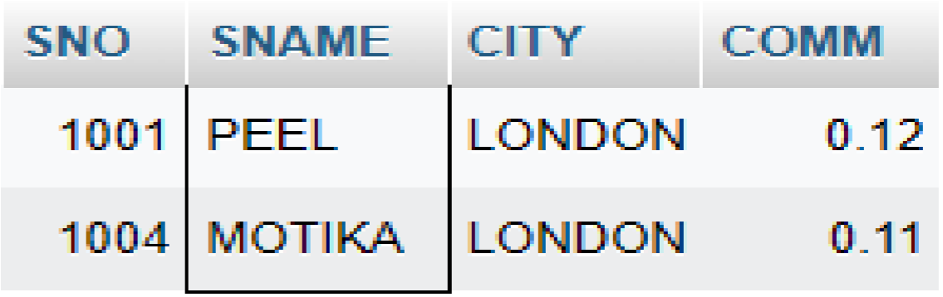

1. All customers whose names begin with a letter from A to B.
   * SELECT * FROM customer WHERE CNAME LIKE

'A%' or CNAME LIKE 'B%';



1. All customers excluding those with rating <=100 unless they are located in Rome.
   * SELECT CNAME FROM customer WHERE RATING

<=100 or CITY='ROME';

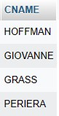

1. All orders except those with 0 or NULL value in amt field.
   * SELECT * FROM orders WHERE AMT <> 0 AND AMT

IS NULL;



1. Count the number of salespeople currently listing in the orders in the order table.
   * SELECT COUNT(DISTINCT SNO)

FROM orders;

